Exercise 1-2

Solving the advection equation using 2 schemes (Lax-Friedrich and Lax-Wendroff) on Jupyter Lab using Python for a step function.

Initial data:

1- Lax-Fredrich scheme:

Using numerical solution for the step function, Figure 1 shows oscillations and dissipation in the function as well as the L2-norm goes to zero:

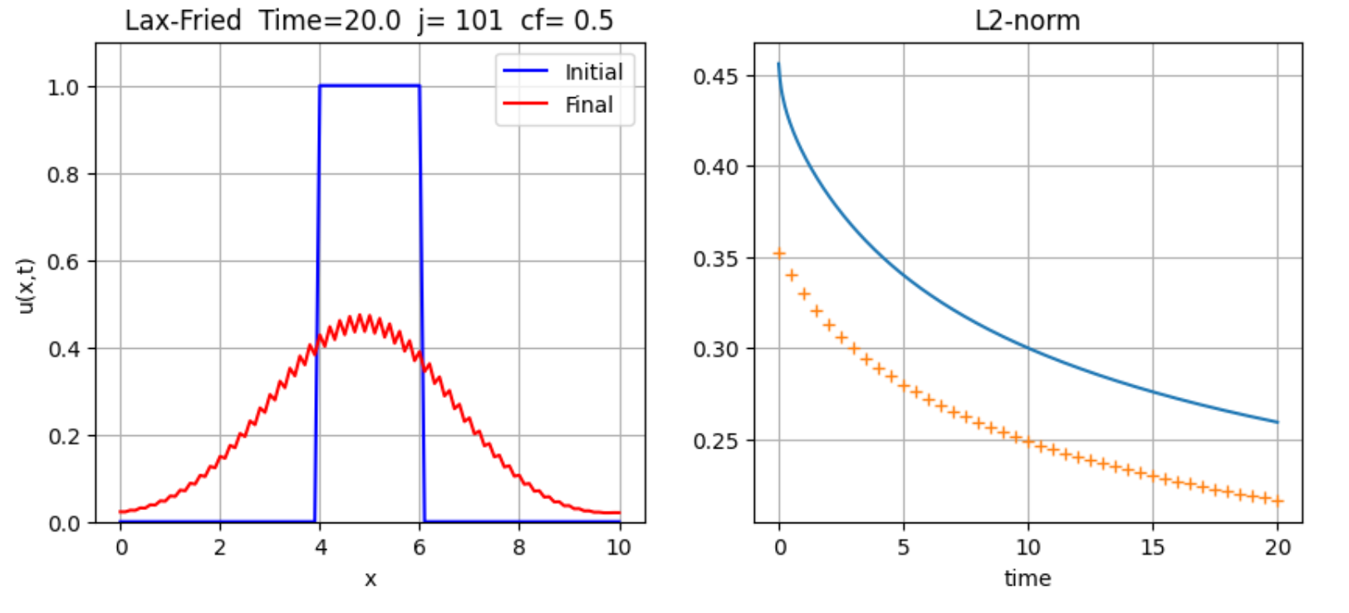

Figure 1: The step function simulation shows perturbations.

Check these snapshots for Figure 1 between the initial function and the final one: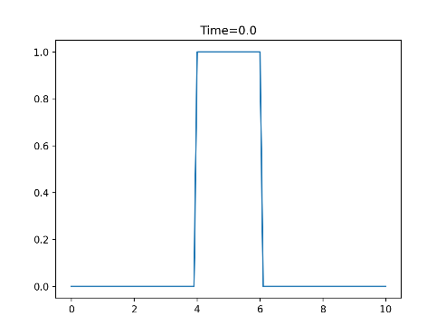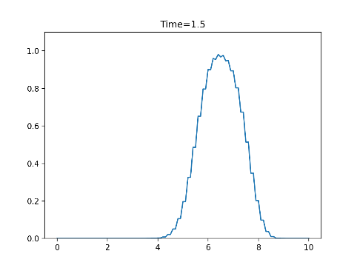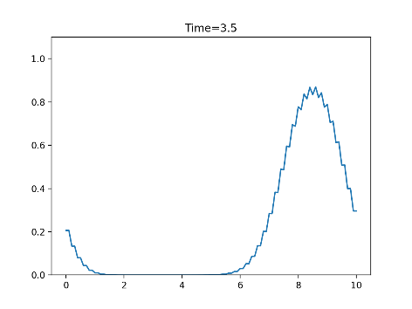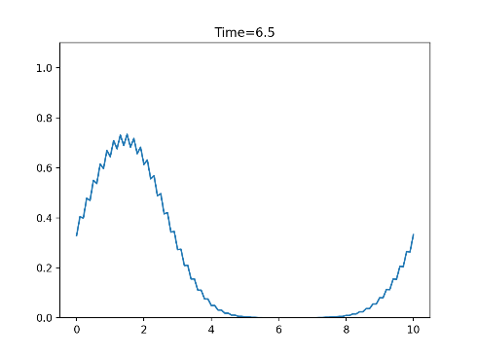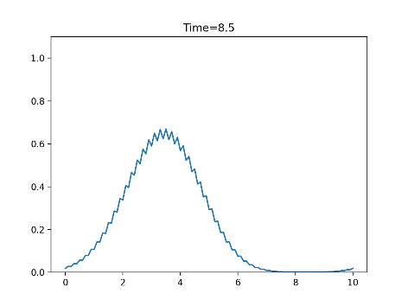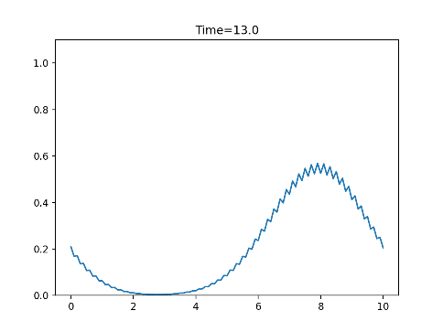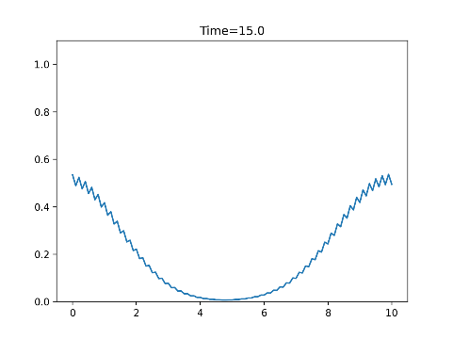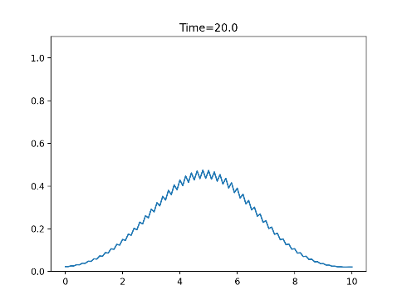

Changing the number of points (j) and cf will make less perturbations and increase the stability of the function as we see in Figure 2 & 3:

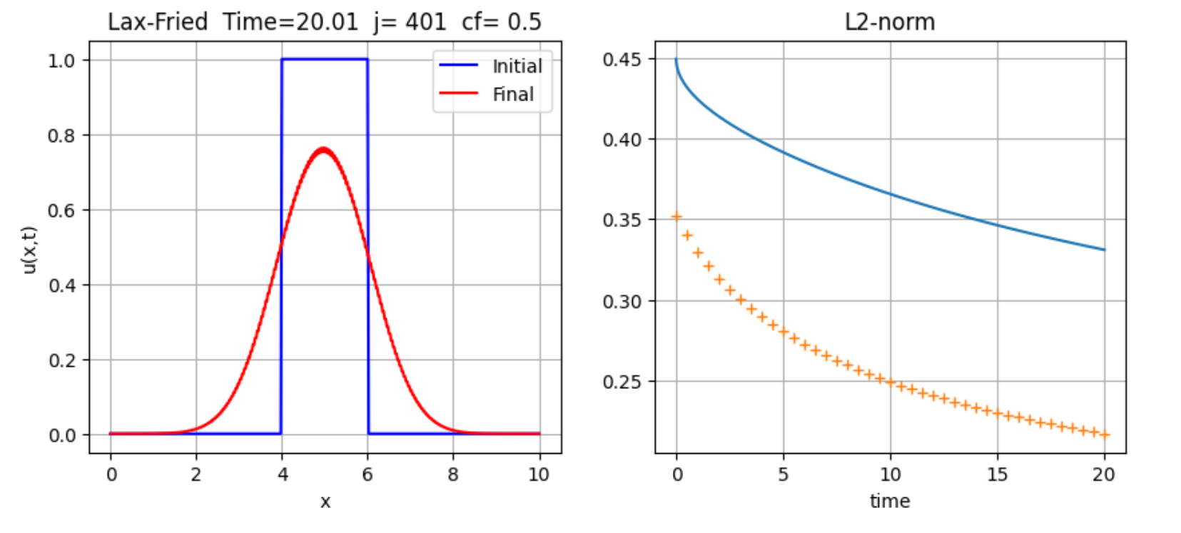

Figure 2: The simulation with higher number of points (j) gives less perturbed function.

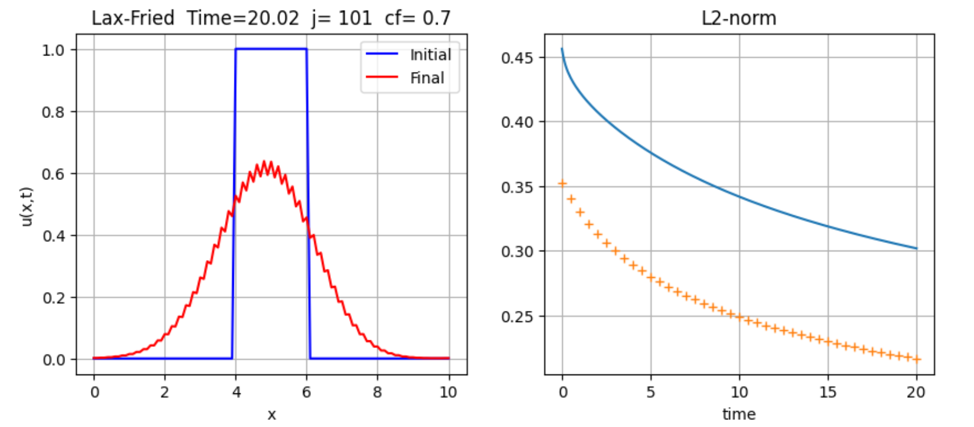

Figure 3: Increasing the cf while j=101. Note the the highest and lowest value of the norm for Figures 1,2&3.

2- Lax-Wendroff scheme:

This scheme shows different behavior as at each jump point the function get disturbed the most, this will be explained after showing Figure 4. For the first simulation to be compared with the Lax-Friedrichs scheme that becomes less with time while for Lax-Wendroff, it has a dispersive behavior as in Figure 4:

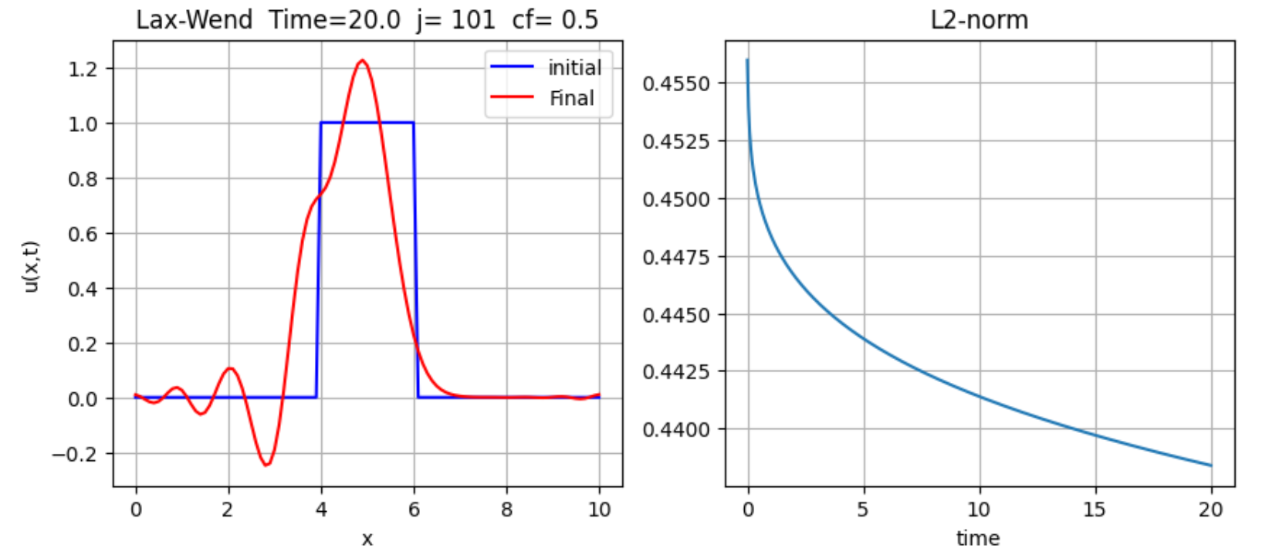

Figure 4: Lax-Wendroff scheme applied for the step function. The L2-norm here is more stable than Lax-Friedrich, compare with Figure 3 & 2

The simulation shows the dispersive behavior before the jump points (at x = 4 & x = 6) as in Figure 5:

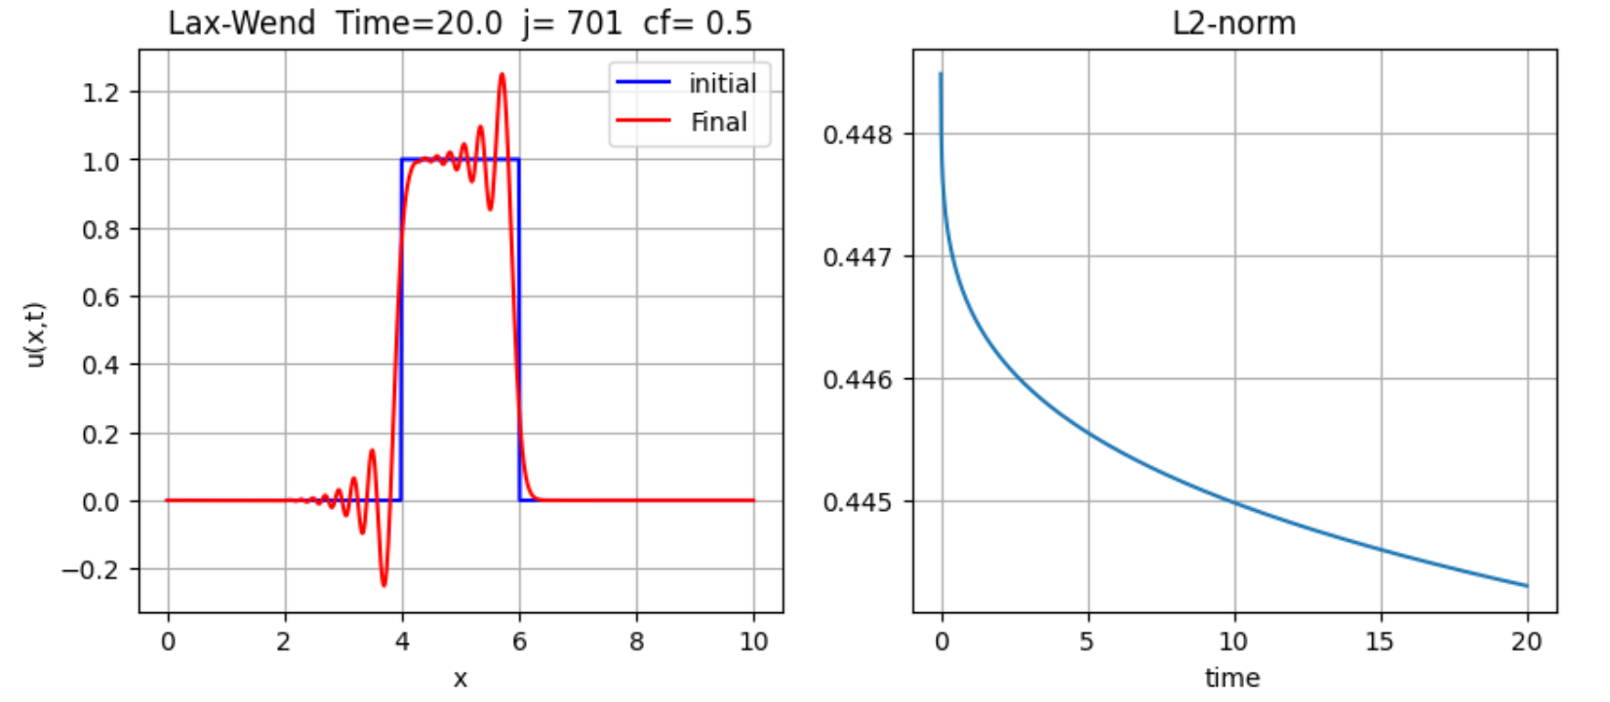

Figure 5: The function is more stable regarding the L2-norm while still shows dispersive behavior in the left plot.

Increasing or decreasing the cf wouldn’t change a lot nor in the simulation nor in the L2-norm as in Figure 6:

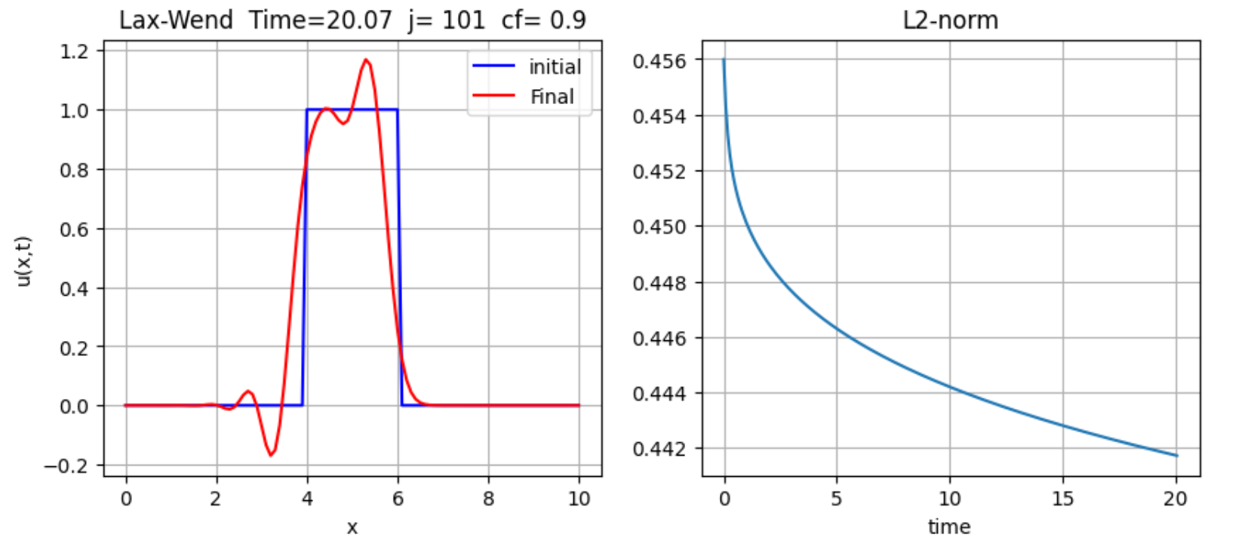

Figure 6: Increasing the cf would make the function more stable but the change is very small in stability as we see in the L2norm.

Finally, I will provide snapshots for the behavior of the function with cf = 0.9 and j = 701 to show the most stable case I did:

